
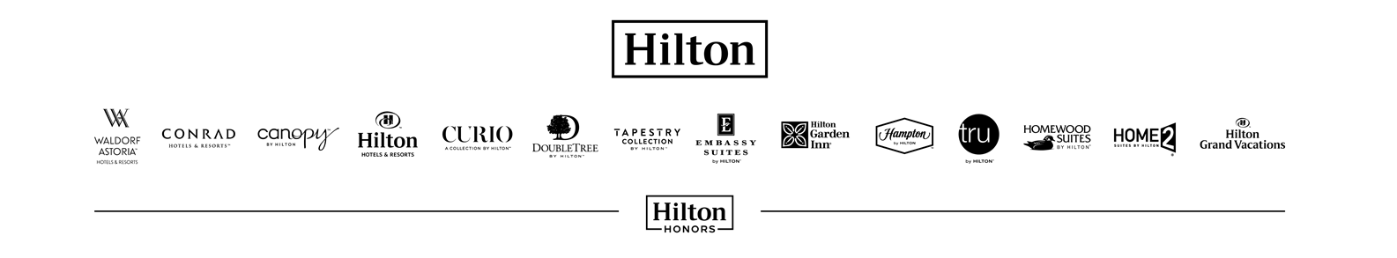
COMPETENCY SUMMARY REPORT
Occupational Personality Questionnaire
Name: Mr Vir Parkash
Location:
Position:
Date: 30 April 2019
1.0 | INTRODUCTION AND BACKGROUND
ABOUT THIS REPORT
This report was generated using the SHL Online Assessment System. It includes information from the Occupational Personality Questionnaire (OPQ32). The use of this report is limited to those people who have received specialist training in its use and interpretation.
The report herein is generated from the results of a questionnaire answered by the respondent and substantially reflects the answers made by them. Due consideration must be given to the subjective nature of questionnaire-based ratings in the interpretation of this data. This report has been generated electronically – the user of the software can make amendments and additions to the text of the report.
SHL Group Ltd and its associated companies cannot guarantee that the contents of this report are the unchanged output of the computer system. We can accept no liability for the consequences of the use of this report and this includes liability of every kind (including negligence) for its contents.
This report has been produced by SHL for the benefit of its client and contains SHL intellectual property. As such, SHL permits SHL's client to reproduce, distribute, amend and store this report for its internal and non-commercial use only. All other rights of SHL are reserved.
1.1 | Purpose  This report is a summary of Mr Vir Parkash’s performance in the individual assessments conducted on 30 April 2019. The information contained in this report was collected by means of an occupational personality assessment which helps determines one’s likely performance against the Hilton Worldwide competencies.  The purpose of this report is to identify the individual’s current strengths and areas for development within Hilton Worldwide’s competency framework. The report provides additional feedback to help the individual with their personal development planning and thereby ensuring that the individual is best placed for future career opportunities.  This report has been prepared specifically for the purpose stated and is based on the information available at the time of the assessment. This report and the information within it is provided on the condition that it is not used for any purpose other than that the purpose it has been prepared for, unless the consent of the candidate has been obtained, and the advice of the assessment provider SHL has been sought. It is highly recommended that the assessment results be used in combination with other information gathered about the candidate.
1.2 | Confidentiality  This report is confidential and it will be essential that the individual concerned should be made aware of the intended recipients of the information.
1.3 | Accuracy  Occupational assessment reports are generally held to be valid for a period of 12-18 months, although this can be considerably shorter if the individual experiences significant life changes. On the expiration of two years from the date of this report, the report should not be used for any purpose whatsoever unless under the consultation of SHL.

2.0 ABILITY TEST RESULTS
This section provides details of Mr Vir Parkash’s scores on the Cognitive Ability Tests.
Mr Vir Parkash’s performance on the assessments is interpreted in relation to a relevant benchmark group.

Numerical Reasoning
Percentile compared to the
General Population 2006 comparison group
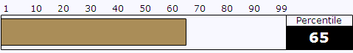
Level: Managerial/Professional
Language: English - International
Mr Vir Parkash’s estimated numerical critical reasoning ability is average when compared to the comparison group. His result is better than 65% of the people in this group. This suggests that he will be as able as most in understanding or interpreting numerical data and mathematical calculations as compared to the group.

-

Verbal Reasoning
Percentile compared to the
General Population 2006 comparison group
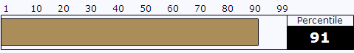
Level: Managerial/Professional
Language: English - International
Mr Vir Parkash’s estimated verbal critical reasoning ability is well above average when compared to the comparison group. His result is better than 91% of the people in this group. This suggests that he will display an exceptional level of ability in understanding and evaluating written reports and documents.

-

3.0 OCCUPATIONAL PERSONALITY QUESTIONNAIRE
This report is intended for use by managers and HR professionals. It summarises how an individual’s preferred style or typical way of behaving is likely to influence their potential performance on Hilton Worldwide’s Global Competency Model.
The degree to which this profile provides an accurate picture of Mr Vir Parkash depends on how consistent, open and honest the individual was in answering the questionnaire. The design of the questionnaire makes it difficult for people to consistently distort their profiles; however, it is always important to corroborate information obtained from one assessment method with at least one more source of information. This is best done through a follow up interview.
The format of the personality questionnaire that the respondent completed (OPQ32r), required one to make forced choices between a range of different statements and the individual's responses were then compared against the responses given by a broad range of other people. The profile overleaf is best viewed as indicating the individual's likely relative strengths and limitations across the competencies.
When considering the description of Mr Vir Parkash's personality, it is important to recognise that it is based on the answers the respondent gave and represents the way they see their own behaviour, rather than how their personality might be described by another person. This self-report can nevertheless give important clues to understanding the way the individual sees their style at work and it is likely to enable us to predict a good deal about their behaviour in different situations. This report links the information from the personality questionnaire to Hilton Worldwide’s competencies.
REPORT KEY
The overall likelihood of Mr Vir Parkash displaying strength in each competency is shown in the bar graphs on the right hand side of the report.
5 | 4 | 3 | 2 | 1
Unlikely to be a strength | Less likely to be a strength | Moderately likely to be a strength | Quite likely to be a strength | Very likely to be a strength
-
Hilton Worldwide Global Competency | 5 | 4 | 3 | 2 | 1
Living the Values* |  |  | NA
Customer Focus
Leadership
Collaboration
Judgment
Results Focus
*This report does not provide feedback on this competency

The ticks, crosses and discs indicate which aspects of Mr Vir Parkash's style are likely to contribute positively or more negatively to each competency.
Symbol | Short Description | Definition
üü | Key Strength | Strongly likely to have a positive impact
ü | Likely Strength | Likely to have a positive impact
l | Moderate | Likely to have neither a positive nor a negative impact
û | Likely Limitation | Likely to have a negative impact
ûû | Key Limitation | Strongly likely to have a negative impact
COMPETENCY POTENTIAL PROFILE
 |  | 5 | 4 | 3 | 2 | 1
Customer Focus
ü | Clear tendency to consider the specific needs of others which is likely to help understanding of customers.
ü | Likely to be quick to take action on customer needs and opportunities.
l | Recognises the need to deliver outcomes in a timely manner, achieving deadlines and meeting customer expectations.
ûû | Likely to express discomfort working at a very busy pace and may not be driven to put in extra effort to meet customer demands.
Leadership
üü | Tends to be very trusting of others, and is very likely to empower others and delegate work.
ü | Is focused on trying to understand others' needs and motivations.
ü | As a leader, is likely to use persuasion and negotiation to motivate and inspire others.
ü | Expresses an interest in assuming responsibility and directing the work of others.
Collaboration
üü | Is very supportive and sympathetic to colleagues.
l | Likely to enjoy spending some time with people but also value having time alone which may have some impact on their relationships.
l | Values co-operation above competition as much as most others.
Judgment
üü | Highly unlikely to take criticism personally so very likely to learn from experience.
l | As comfortable as most using facts and data to make decisions.
l | Expresses some willingness to stand alone on ideas and opinions.
Results Focus
üü | Highly likely to have the end goal in mind and focus on the longer term impact on the customer.
ü | Clear tendency to take ownership or accountability for delivering results.
l | As likely as most to be motivated through delivering results and exceeding expectations.
û | Expresses a dislike for following set procedures/regulations, which may undermine quality customer outcomes.

